1. Total karma points against an individual employee.

Query :- SELECT user_profile.USER_ID, empl_level.REPUTATION_POINTS

FROM user_profile JOIN empl_level

WHERE user_profile.USER_PROFILE_SEQ = empl_level.USER_PROFILE_SEQ AND

user_profile.USER_ID = "[sameer.more@ripplehire.com](mailto:sameer.more@ripplehire.com)";

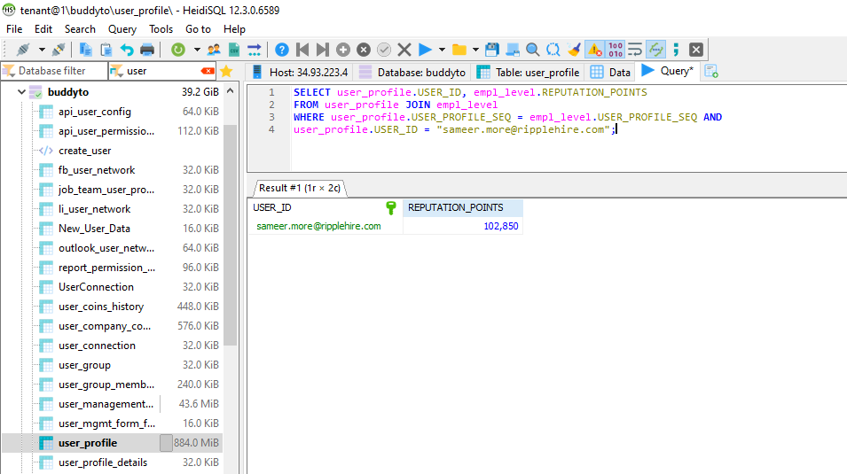

1. Current level of employee user.

Query :- SELECT user_profile.USER_ID, empl_level.COMPLETED_LEVEL

FROM user_profile, empl_level

WHERE user_profile.USER_PROFILE_SEQ = empl_level.USER_PROFILE_SEQ AND

user_profile.USER_ID = "sameer.more@ripplehire.com";

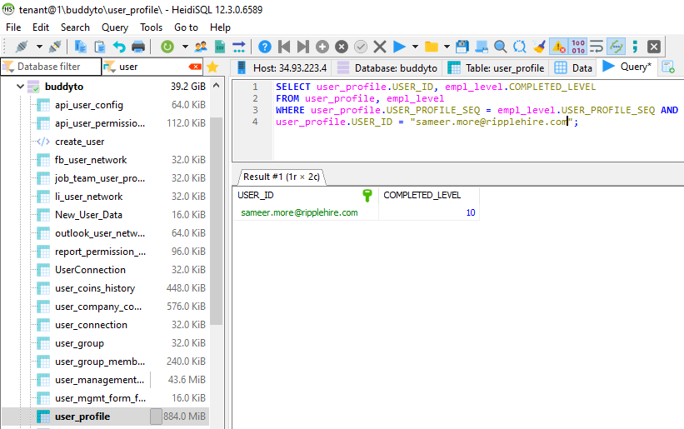

1. List of completed goals for employee users.

Query :- SELECT u.USER_ID, empg.GOAL_SEQ, g.GOAL_DESC

FROM user_profile u JOIN empl_goal empg

ON u.USER_PROFILE_SEQ = empg.USER_PROFILE_SEQ

JOIN goal g ON empg.GOAL_SEQ = g.GOAL_SEQ

WHERE u.USER_ID = "sameer.more@ripplehire.com" LIMIT 5;

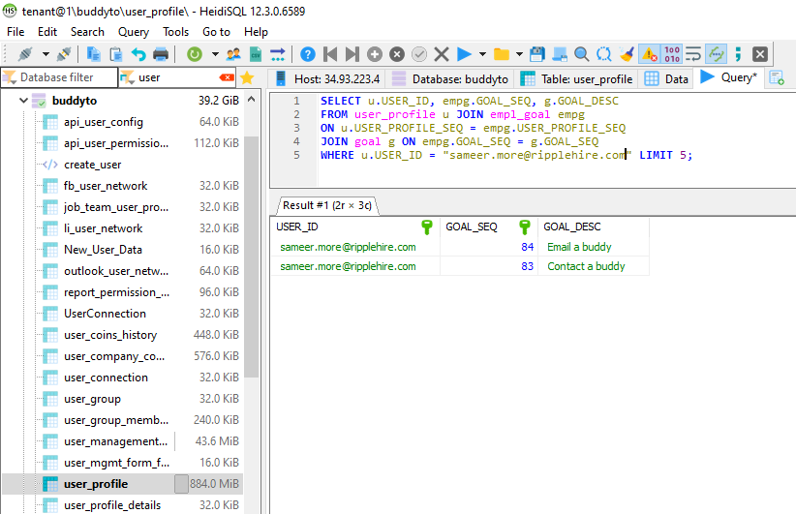

1. List different badges which an employee has earned till now.

Query :- SELECT u.USER_ID, empb.REWARD_BADGE_SEQ, rg.BADGE_CD, rg.BADGE_LBL,

rg.BADGE_DESC

FROM user_profile u JOIN empl_badge empb

ON u.USER_PROFILE_SEQ = empb.USER_PROFILE_SEQ

JOIN reward_badge rg

ON empb.REWARD_BADGE_SEQ = rg.REWARD_BADGE_SEQ

WHERE u.USER_ID = "sameer.more@ripplehire.com";

